Breast Cancer Surveillance Consortium

The dataset includes information from between January 2005 and December 2017. The dataset includes characteristics previously shown to be associated with breast cancer.

Features: 13 clinical & demographic factors
- age,
- race/ethnicity,
- family history of breast cancer,
- age at menarche,
- age at first birth,
- breast density,
- use of hormone
- replacement therapy,
- menopausal status,
- body mass index,
- history of biopsy,
- history of breast cancer

- BCSC_risk_factors_summarized_1_092020 – contains 506,465 records
- BCSC_risk_factors_summarized_2_092020 – contains 506,465 records
- BCSC_risk_factors_summarized_3_092020 – contains 509,410 records

✔ Total records: 1,522,340

3️. Data Preprocessing & Cleaning

- Steps Taken
✔ Merged the 3 datasets into one large dataset
✔ Checked and handled missing values (Filled categorical missing values with mode)
✔ Encoded categorical features using Label Encoding
✔ Normalized numerical features using StandardScaler (Age & Year)
✔ Filtered the target variable (breast_cancer_history) to ensure binary classification (0 or 1)
✔ Balanced the dataset using SMOTE (Synthetic Minority Over-sampling Technique)

📊 Class Distribution Before & After Balancing
- Before SMOTE: Highly imbalanced (fewer cancer cases)
- After SMOTE: Balanced dataset with equal representation
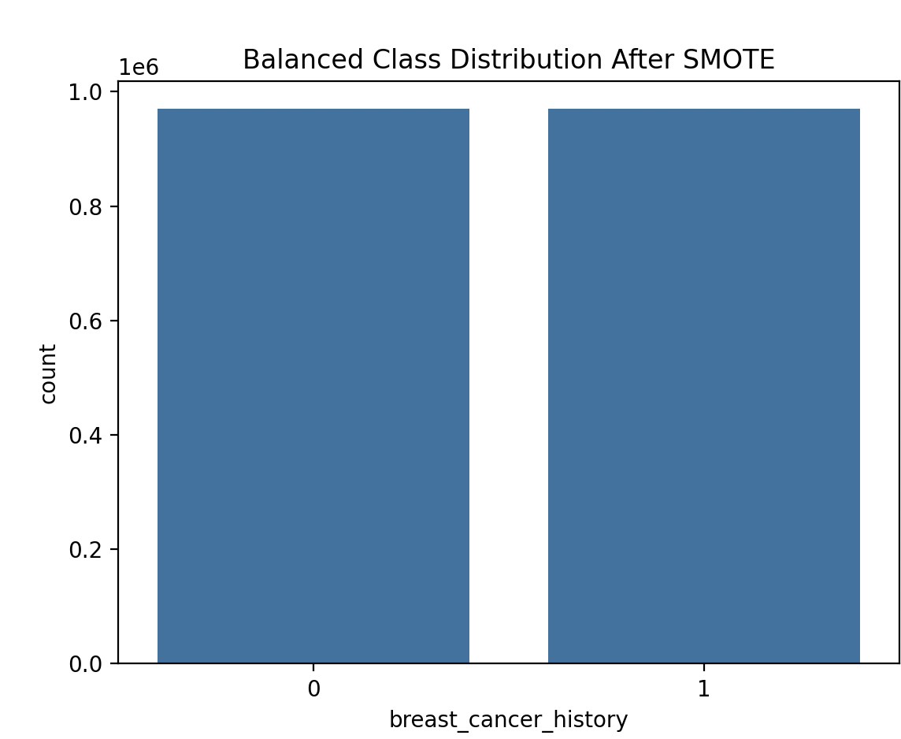

4️. Model Training & Evaluation
Trained and compared three machine learning models to evaluate performance:

1️. Logistic Regression (Baseline Model)
Metric | Logistic Regression Score
Accuracy | 71.56%
AUC Score | 71.56%
Precision (No Cancer - 0) | 73%
Recall (No Cancer - 0) | 69%
Precision (Cancer - 1) | 70%
Recall (Cancer - 1) | 74%

Key Observations
- Logistic Regression achieved low accuracy (71.56%)
- Recall was moderate but led to a high number of false negatives (missed cancer cases).

Confusion matrix:

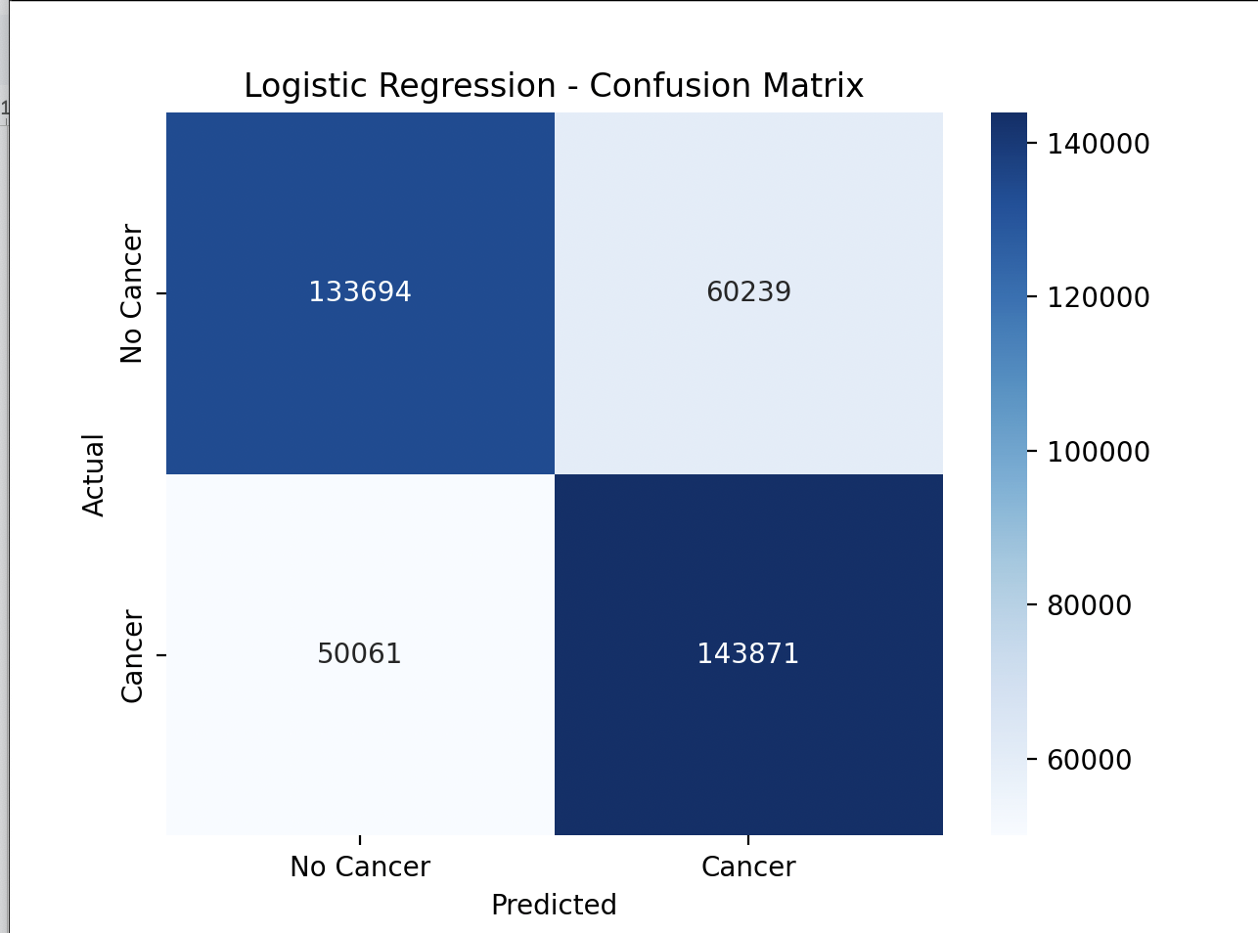

2️. XGBoost Model (Best Performing)
Metric | XGBoost Score
Accuracy | 86.17%
AUC Score | 86.17%
Precision (No Cancer - 0) | 83%
Recall (No Cancer - 0) | 91%
Precision (Cancer - 1) | 90%
Recall (Cancer - 1) | 81%
Key Observations
✔ Highest accuracy (86.17%) among all models
✔ High recall for No Cancer (91%), meaning fewer false positives
✔ Lower recall for Cancer cases (81%), meaning it missed some cancer cases
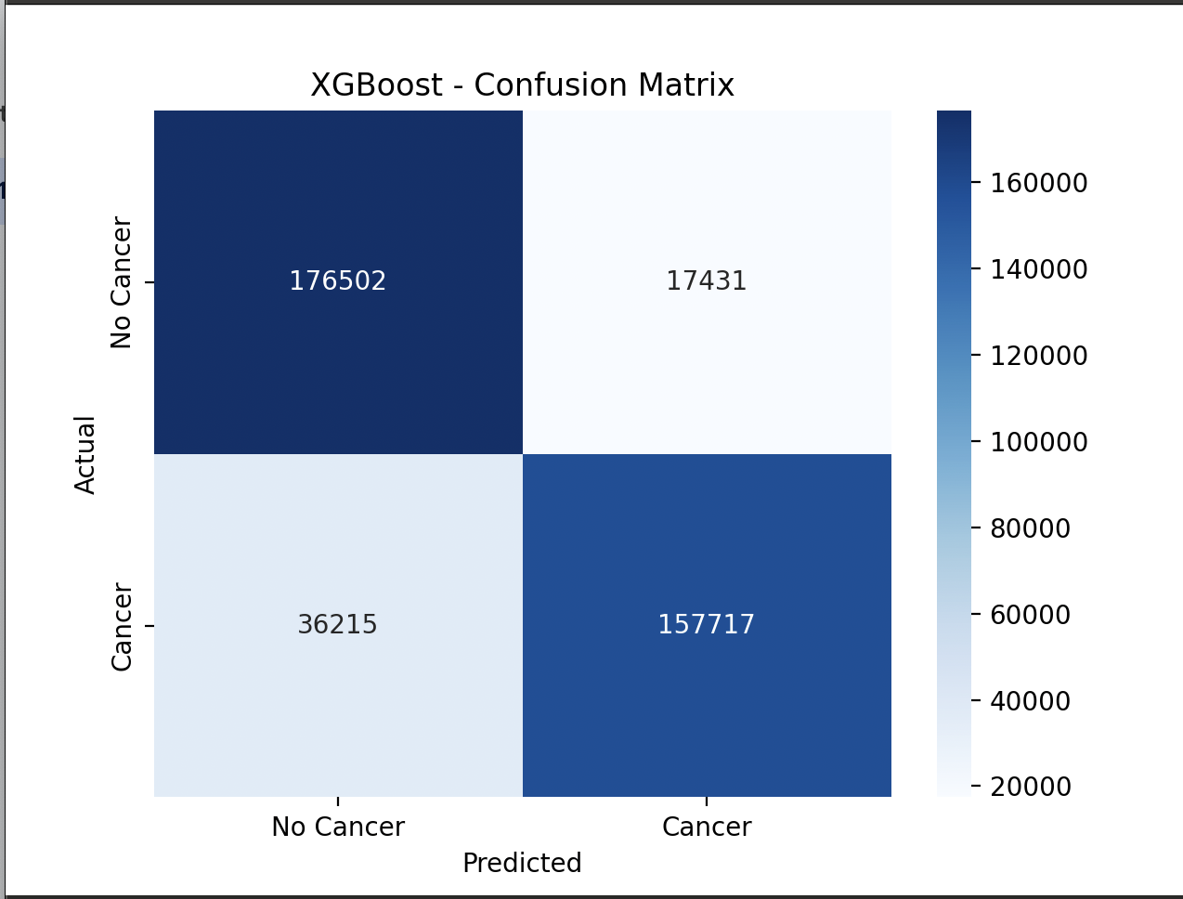

3️. Random Forest Model (Balanced Performance)
Metric | Random Forest Score
Accuracy | 83.25%
AUC Score | 83.25%
Precision (No Cancer - 0) | 84%
Recall (No Cancer - 0) | 82%
Precision (Cancer - 1) | 83%
Recall (Cancer - 1) | 84%
Key Observations
✔ Higher recall for cancer cases (84%) compared to XGBoost (81%)
✔ Balanced precision and recall for both classes
✔ Slightly lower accuracy (83.25%) compared to XGBoost
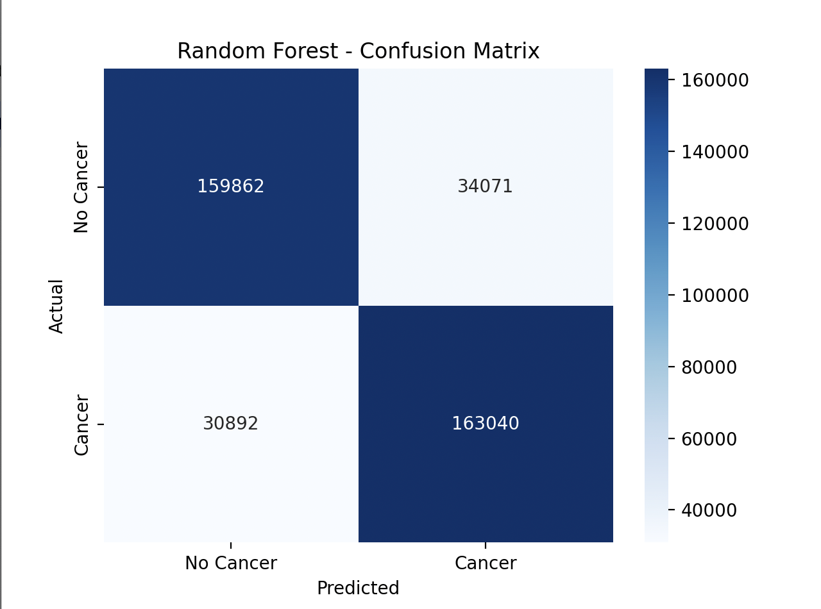

5️. Final Model Comparison
Model | Accuracy | Precision (No Cancer) | Recall (No Cancer) | Precision (Cancer) | Recall (Cancer)
Logistic Regression | 71.56% | 73% | 69% | 70% | 74%
XGBoost | 86.17% | 83% | 91% | 90% | 81%
Random Forest | 83.25% | 84% | 82% | 83% | 84%
- XGBoost has the highest accuracy (86.17%), but lower recall for Cancer cases (81%)
- Random Forest has balanced recall across both classes (82% & 84%)
- Logistic Regression is the least effective model due to its low accuracy (71.56%)

- tested lowering the threshold to 0.38 (XGBoost) & 0.39 (Random Forest).
- This increased recall but lowered precision
Problem: Lowering the threshold made precision much worse, it falsely predicted cancer in too many cases.

